Lab Exercise 24 - Default vs Per-Object Retention in MinIO Object Lock

1. Objective
By the end of this lab, you will:
- Understand default bucket retention
- Apply per-object retention
- Observe retention precedence
- Verify behavior using MinIO CLI
- Understand real-world compliance use cases

2. Prerequisites
- MinIO server running
- mc (MinIO Client) installed
- Admin credentials available
- Version: MinIO with Object Lock support
- Port 9000 accessible

3. Key Concepts (Before You Start)
Concept | Meaning
Default Retention | Applied automatically to all new objects
Per-Object Retention | Overrides default for specific objects
Versioning | Mandatory for Object Lock
Compliance Mode | Retention cannot be shortened or removed
Governance Mode | Retention can be overridden by privileged users

4. Step 1: Set MinIO Alias
mc alias set myminio http://localhost:9000 minioadmin minioadmin
Expected:
Added `myminio` successfully.

5. Step 2: Create Lock-Enabled Bucket
Object Lock must be enabled at bucket creation time
mc mb --with-lock myminio/retention-lab
Verify:
mc ls myminio

6. Step 3: Verify Versioning
mc version info myminio/retention-lab
Expected:
Versioning is enabled
Object Locking is enabled

7. Step 4: Set Default Bucket Retention
Set default retention:
- Mode: GOVERNANCE
- Duration: 7 days
mc retention set --default GOVERNANCE 7d myminio/retention-lab

Verify:
mc retention info myminio/retention-lab

Expected:
Mode: GOVERNANCE
Duration: 7 days

8. Step 5: Upload Object (Default Retention Applies)
echo "default retention file" > default.txt
mc cp default.txt myminio/retention-lab/

Check retention:
mc stat myminio/retention-lab/default.txt

Expected:
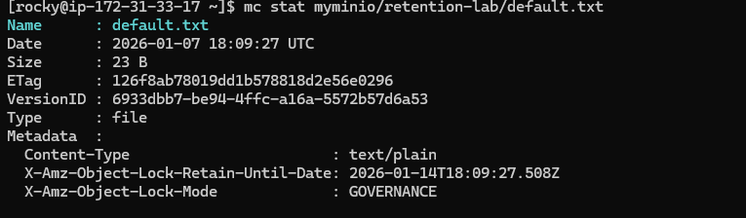
Default retention applied automatically

9. Step 6: Upload Object with Per-Object Retention (Override)
Create file:
echo "per object retention" > custom.txt

Upload with COMPLIANCE mode for 30 days:
mc cp \
--retention-mode compliance \
--retention-duration 30d \
custom.txt myminio/retention-lab/

Verify:
mc stat myminio/retention-lab/custom.txt
Expected:
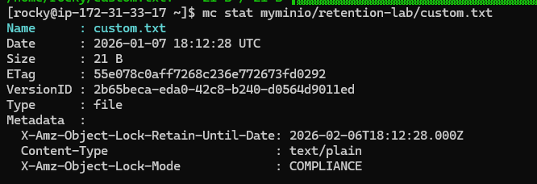
Per-object retention overrides default

